# **Range Rover Sport (L320)/Discovery LR3/LR4 2005-2014**

Land Rover Range Rover Sport (L320)/Discovery LR3/LR4 2005-2014 Air Suspension System has Front and Rear Air Spring Bag Strut Assemblies in which the Air Spring Bag and Shock Absorber works as a unit. Height Sensors tell the Control Module when the Air Suspension Compressor needs to inflate or deflate the Air Suspension System. The Solenoid Valve Block will distribute the Air accordingly trough out the Air Suspension System. Here at BAVARIA CENTER you will find many of the necessary parts and components to fix your Land Rover Range Rover Sport (L320)/Discovery LR3/LR4 2005-2014 Air Suspension System. Your satisfaction is our guarantee!

# **Land Rover Range Rover SPORT (L320)/Discovery Lr3/Lr4 Air Strut Shock Absorber Air suspension front**

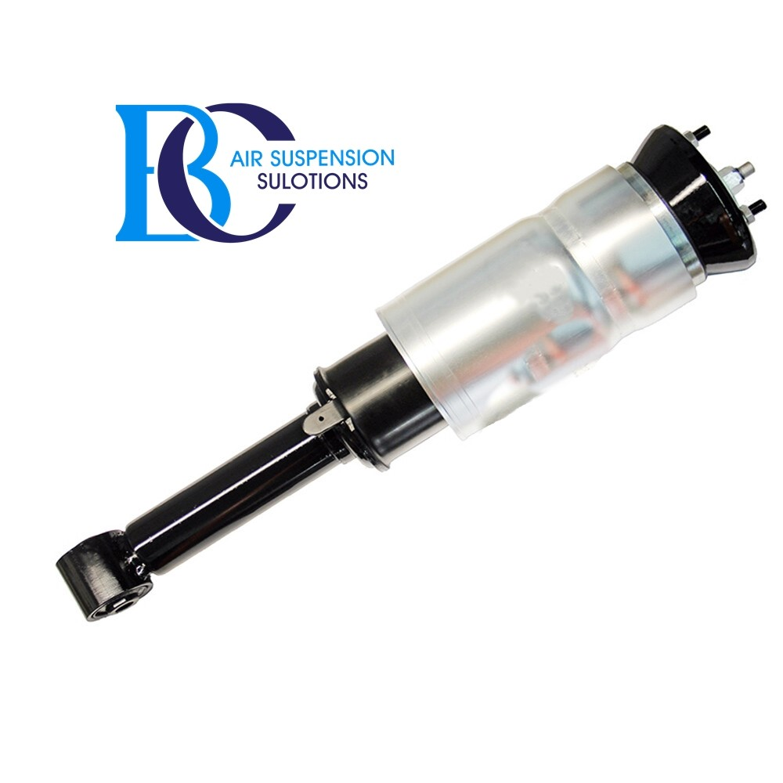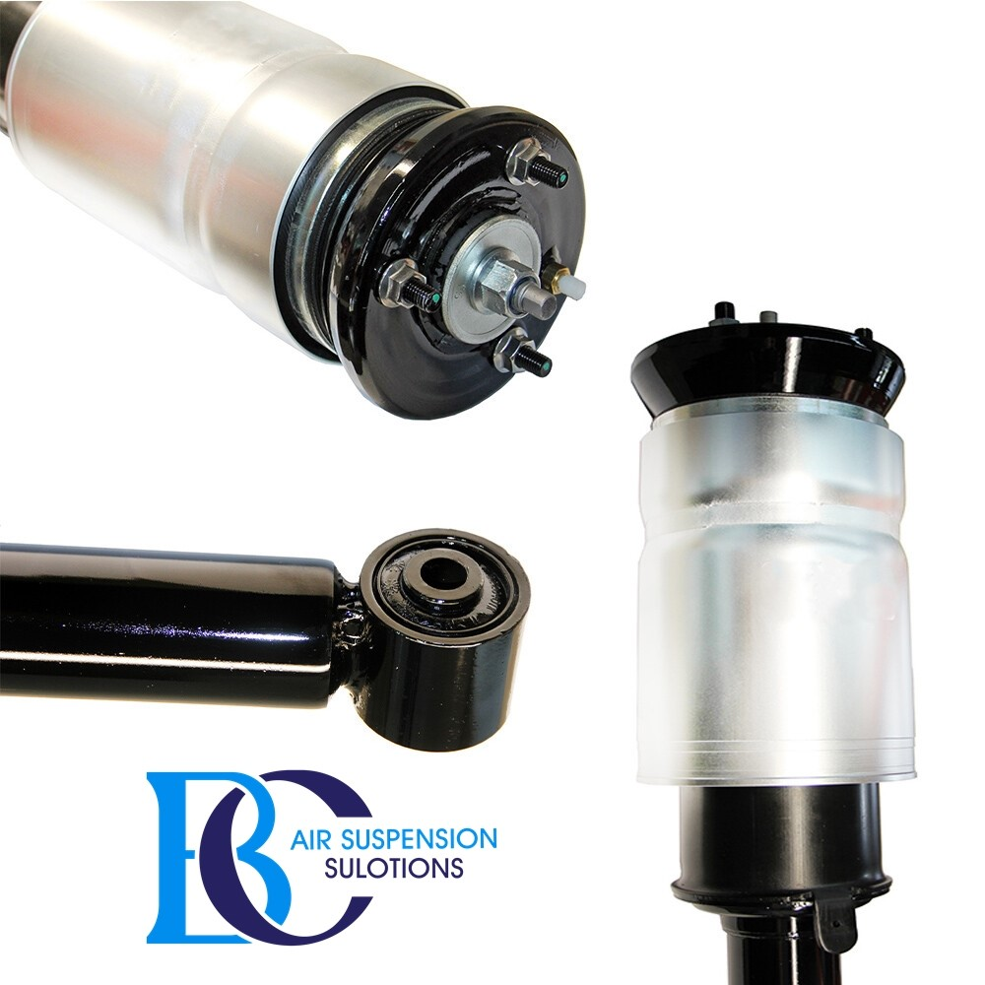

Description

This is air strut shock absorber for front side.

**Can be installed in the following vehicles:**

Land Rover Range Rover Sport (excl. Supercharged) (2005-2014)

Land Rover Range Rover Sport (Incl. Supercharged) (2005-2009)

Land Rover Range Rover Discovery Lr3

Land Rover Range Rover Discovery Lr4

**OEM part number:**

LR016416, LR041108, LR016415, RNB501620, RNB501460, RNB501600, RNB501470,

RNB501180, RNB000855, LR016414, LR034282, RNB501590, LR034283, RNB501480,

RNB501610, LR058022, LR034284

# **Range Rover Sport L320/Discovery Lr3/Discovery Lr4 (FRONT)**

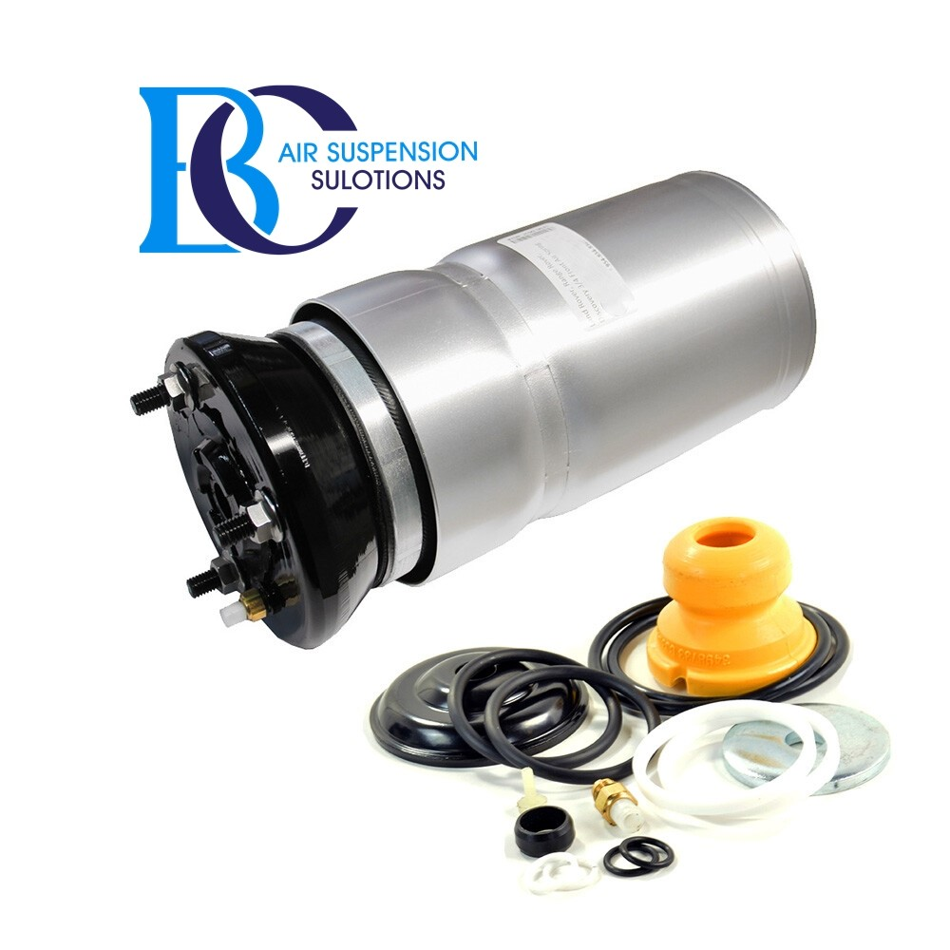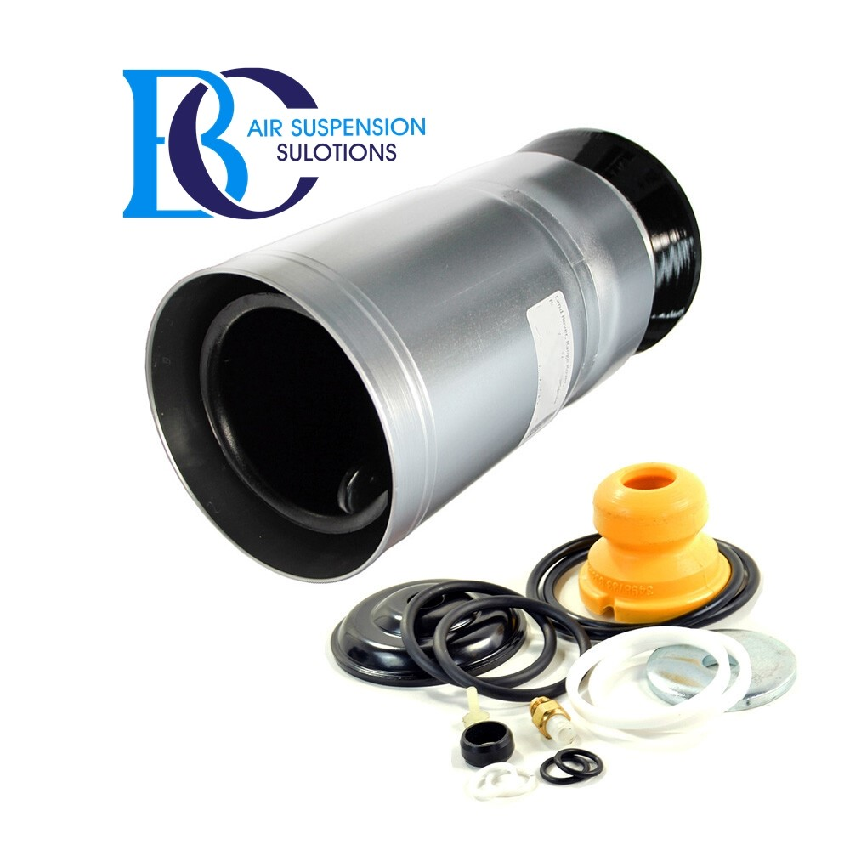

Description

This is a new air spring for front side.

**It can be installed in the following vehicles:**

Land Rover Range Rover Sport (excl. Supercharged) (2005-2014)

Land Rover Range Rover Sport (Incl. Supercharged) (2005-2009)

Land Rover Range Rover Discovery Lr3

Land Rover Range Rover Discovery Lr4

**OEM part numbers:**

LR016403, REB500010, REB500060, REB500190

# **Land Rover Rover Range Rover SPORT (L320)/DISCOVERY LR3/LR4 Air suspension strut rear**

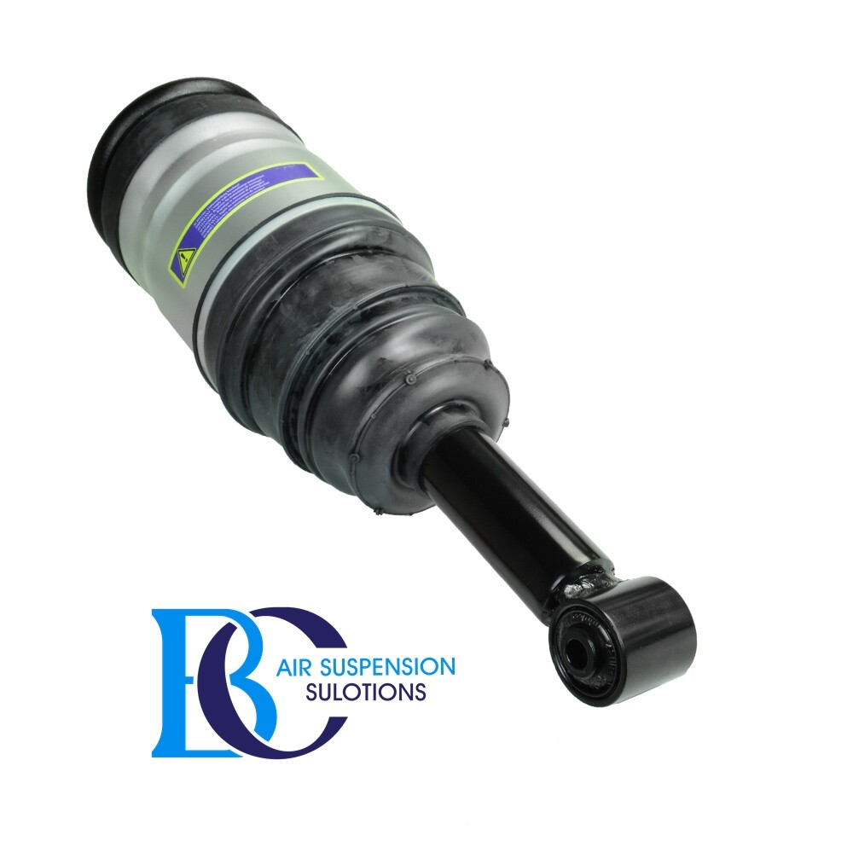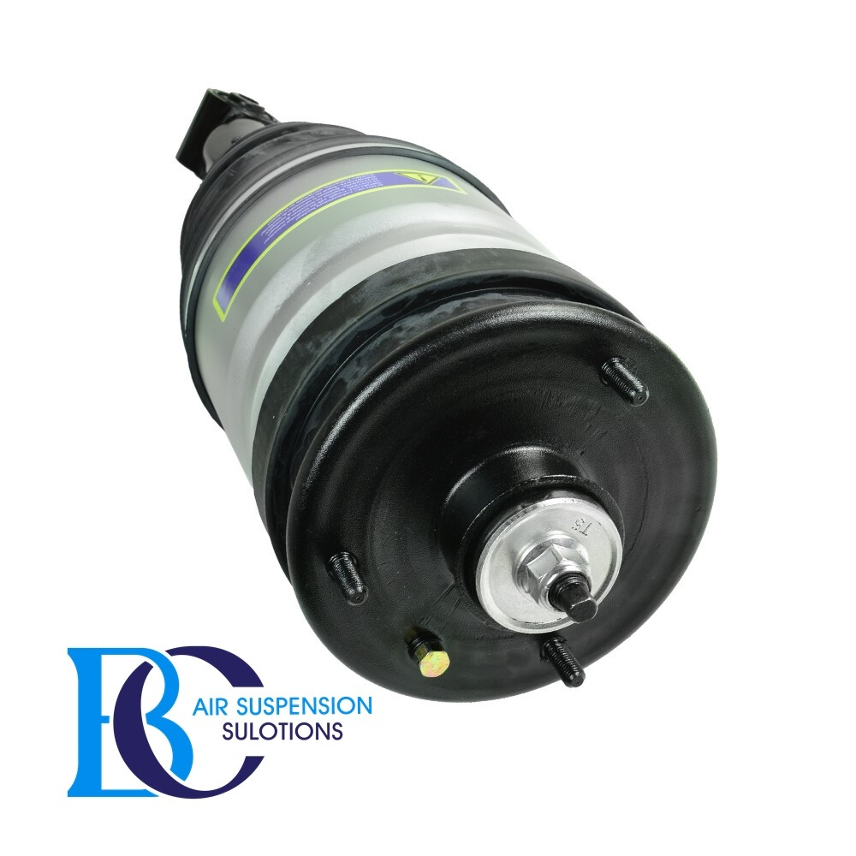

**Description**

This is the rear air suspension strut for the Land Rover Rover Range Rover SPORT (L320)/ Discovery Lr3/Lr4.

**Can be installed in the following vehicles:**

Land Rover Range Rover Sport (excl. Supercharged) (2005-2014)

Land Rover Range Rover Sport (Incl. Supercharged) (2005-2009)

Land Rover Range Rover Discovery Lr3

Land Rover Range Rover Discovery Lr4

**OEM part number:**

LR041110, LR016419, LR016418, RPD501100, RPD501020, LR034287, LR038096, LR032650, LR014195

# **Land Rover Range Rover Sport L320/Discovery Lr3/Lr4 Air spring (REAR)**

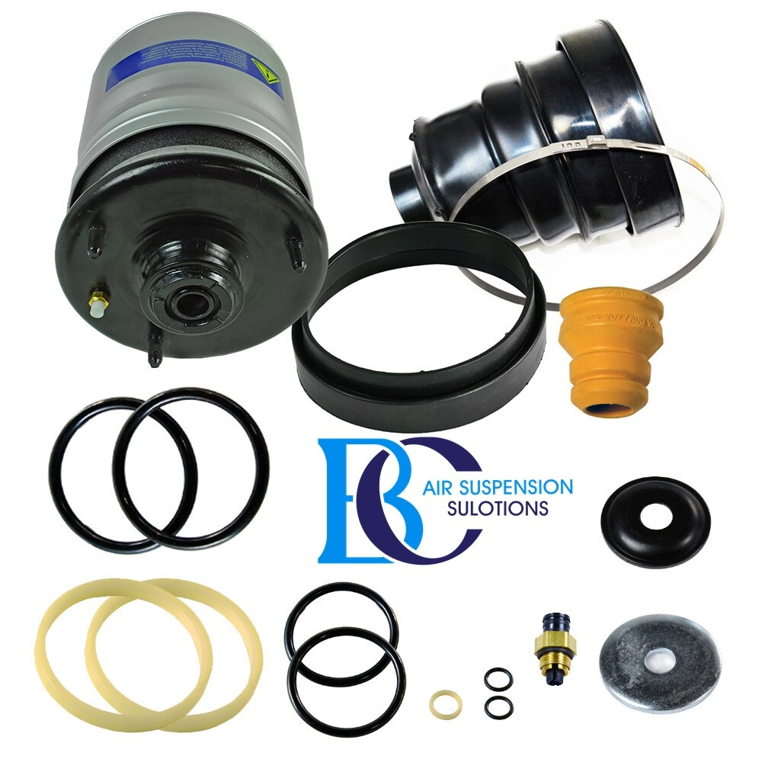

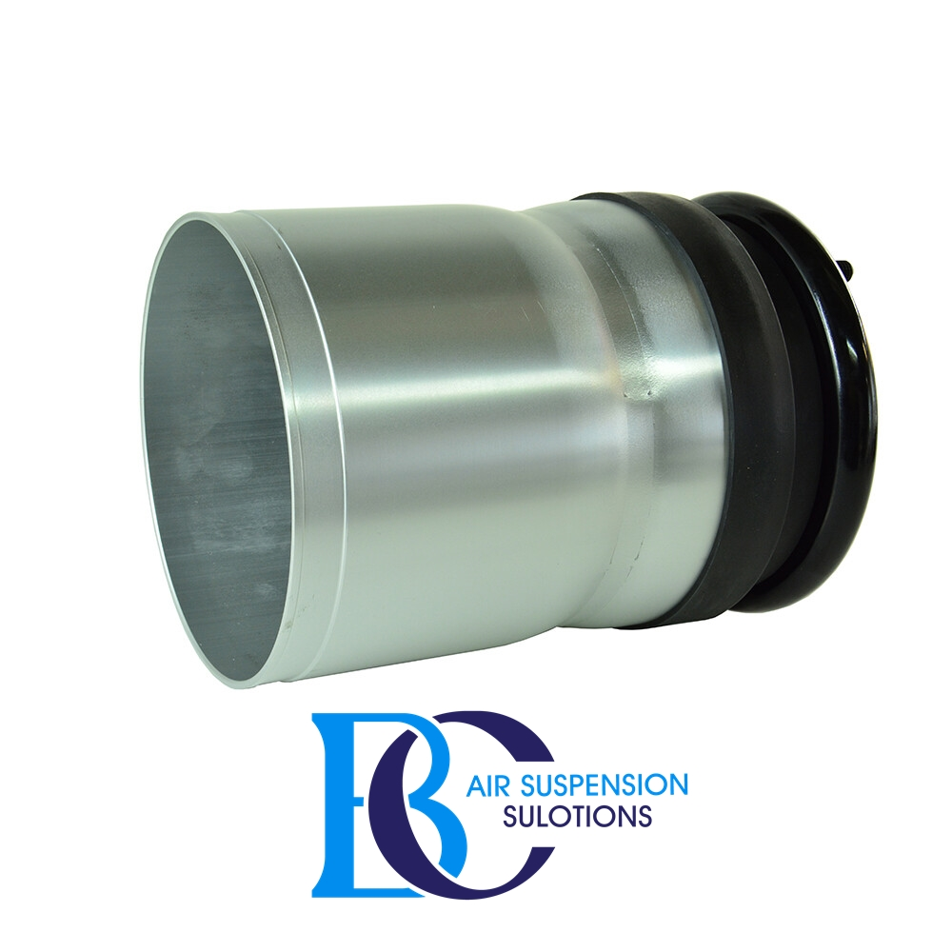

**Description**

This is a new air spring for rear side.

This repair kit should not be used for oil end shock absorbers.

If the air strut is broken, but the shock absorber still has the best properties, you can use this set to restore the function of the complete shock absorber.

**Can be installed in the following vehicles:**

Land Rover Range Rover Sport (excl. Supercharged) (2005-2014)

Land Rover Range Rover Sport (Incl. Supercharged) (2005-2009)

Land Rover Range Rover Discovery Lr3

Land Rover Range Rover Discovery Lr4

**OEM part numbers:**

LR016411, RKB500010, RKB500140, RKB500250

# **Land Rover SPORT (L320)/Discovery Lr3/Lr4 Compressor air suspension**

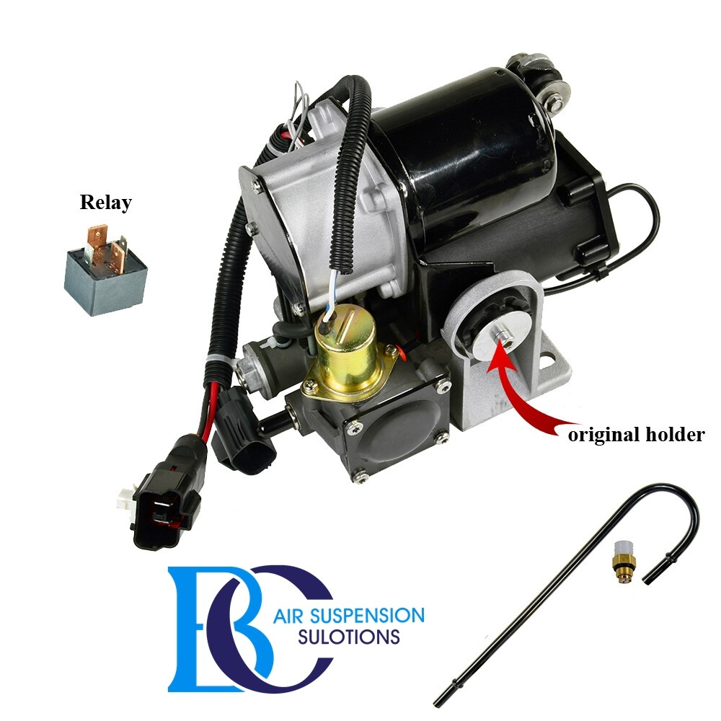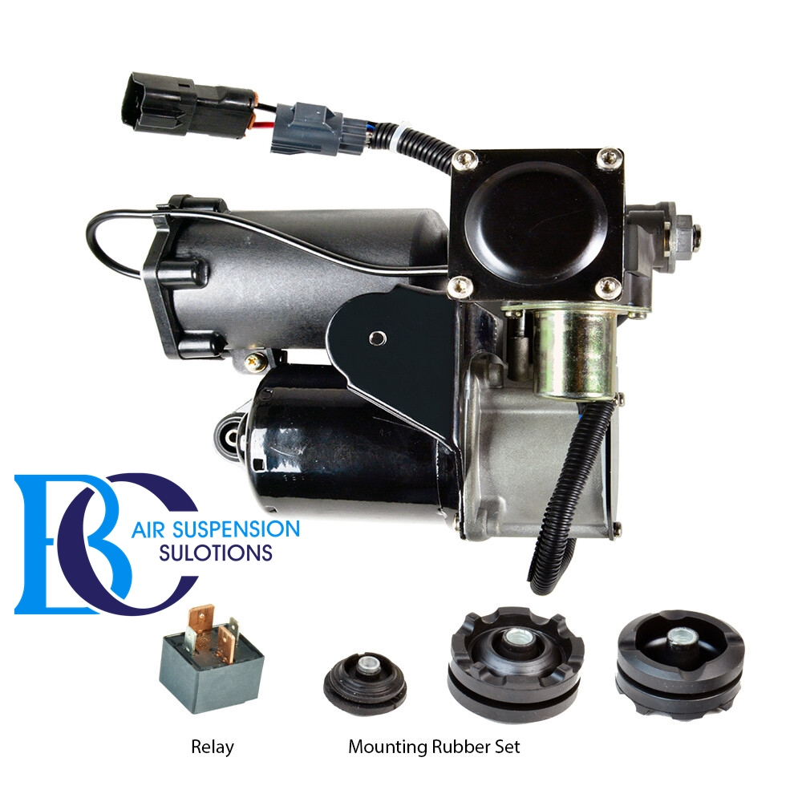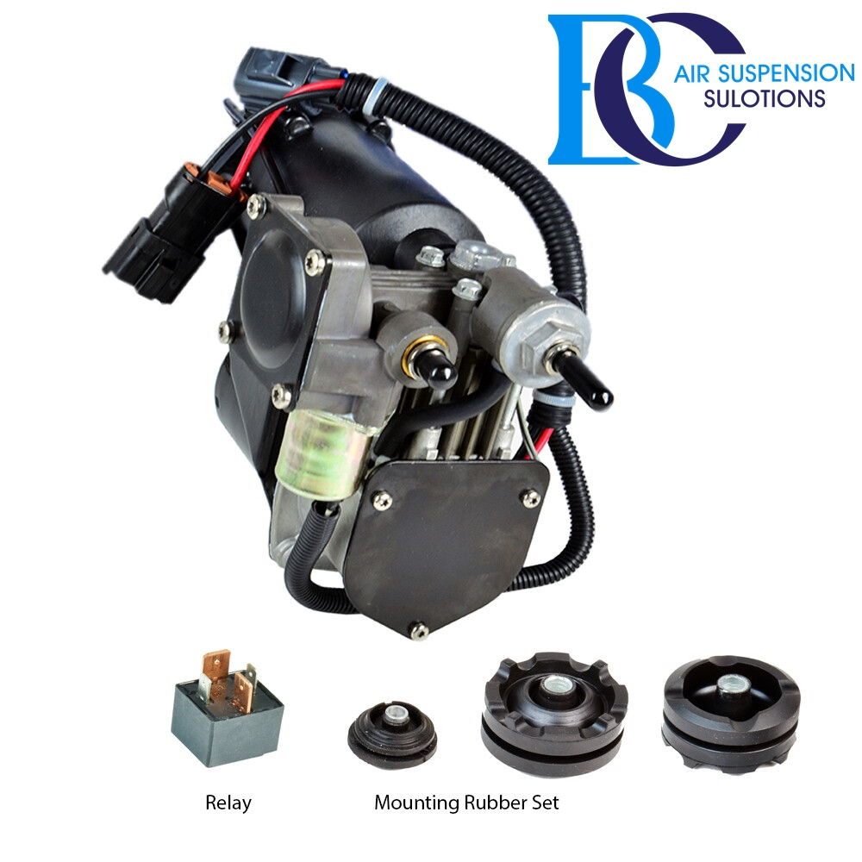

**Description:**

This is air suspension compressor for the Land Rover SPORT (L320)/Discovetry Lr3/Lr4.

**Can be installed in the following vehicles:**

Land Rover Range Rover Sport (excl. Supercharged) (2005-2014)

Land Rover Range Rover Sport (Incl. Supercharged) (2005-2009)

Land Rover Range Rover Discovery Lr3

Land Rover Range Rover Discovery Lr4

**OEM part number:**

LR072537, LR061663,LR006200, LR010376, LR010414, LR011837, LR015303, LR023964, LR032902, LR037065, LR038114,LR038115, LR038116, LR038117, LR038118, LR038148, LR041776, LR044360, LR045251

# **Land Rover Range Rover SPORT (L320)/Discovery Lr3/Lr4 Valve Air Suspension**

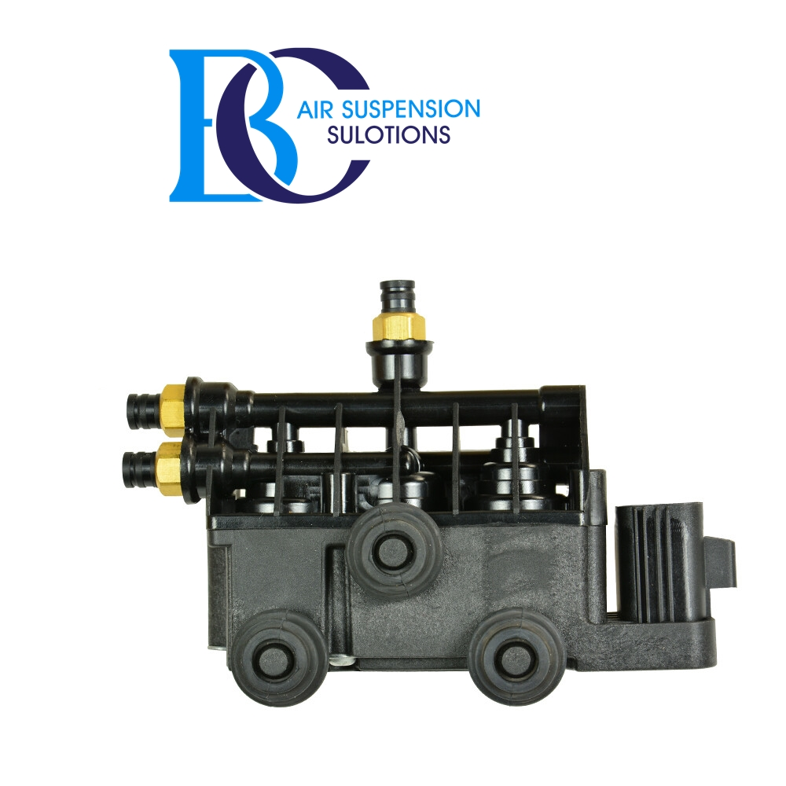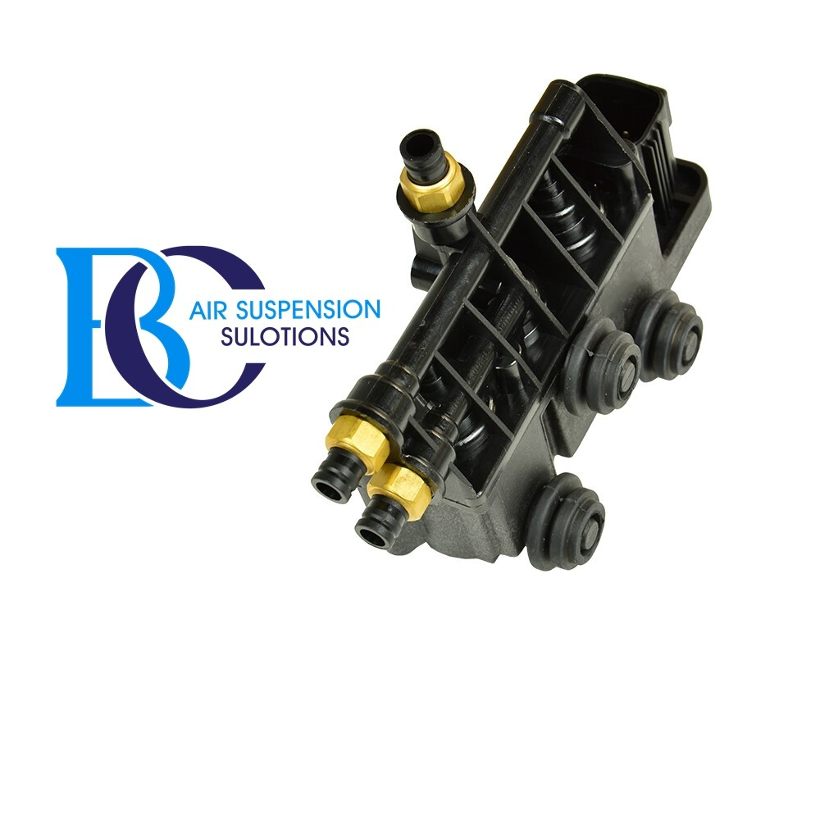

**Description**

This Land Rover Range Rover Sport L320/Discovery Lr3/Lr4 Air Suspension Control Valve (RVH000055) regulates the height control of the air suspension.

**Can be installed in the following vehicles:**

Land Rover Range Rover Sport (excl. Supercharged) (2005-2014)

Land Rover Range Rover Sport (Incl. Supercharged) (2005-2009)

Land Rover Range Rover Discovery Lr3

Land Rover Range Rover Discovery Lr4

**OEM part number:**

RVH000055

# **Land Rover Range Rover SPORT (L320)/Discovery Lr3/Lr4 Valve Air Suspension**

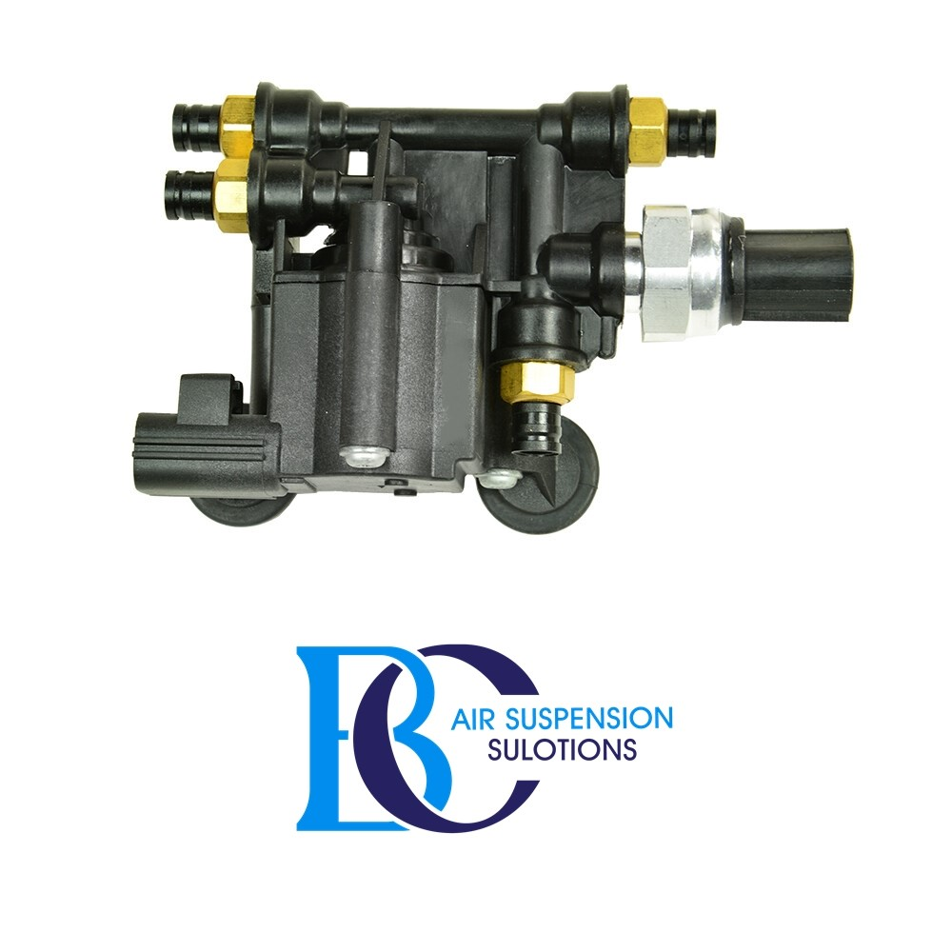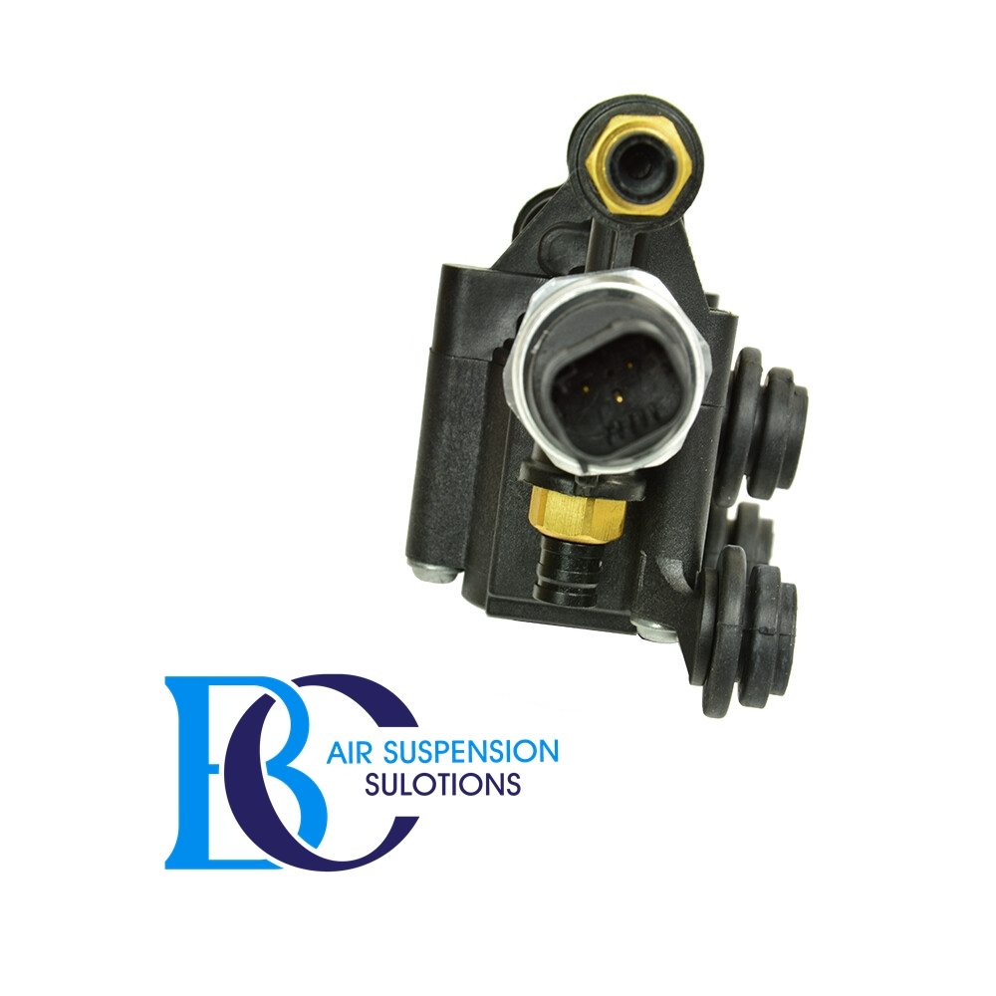

**Description**

This Land Rover Range Rover Sport L320/Discovery Lr3/Lr4 Air Suspension Control Valve (RVH000046) regulates the height control of the air suspension.

**Can be installed in the following vehicles:**

Land Rover Range Rover Sport (excl. Supercharged) (2005-2014)

Land Rover Range Rover Sport (Incl. Supercharged) (2005-2009)

Land Rover Range Rover Discovery Lr3

Land Rover Range Rover Discovery Lr4

**OEM part number:**

RVH000046